JAVA TEST-1

H.MADHUMITHAA

192211308

1. Find the LCM and GCD of n numbers?

import java.util.Scanner;

class gcd

{

public static void main(String args[])

{

Scanner input=new Scanner(System.in);

System.out.print("Enter the number1:");

int n1=input.nextInt();

System.out.print("Enter the number2:");

int n2=input.nextInt();

int lcm=n1\*n2;

int g;

do

{

if(n1>n2)

n1=n1-n2;

else

n2=n2-n1;

}

while(n1!=n2);

g=n1;

System.out.print("Gcd of two numbers:"+g);

lcm=lcm/g;

System.out.print("\nLcm of two numbers:"+lcm);

}

}

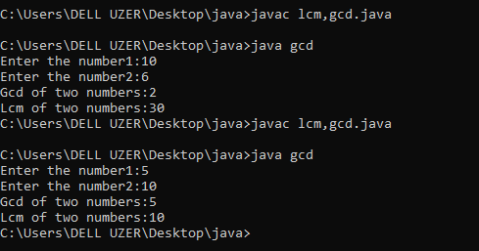

2.Write a program to print Right Triangle Star Pattern

import java.util.Scanner;

class star {

public static void main(String[] args) {

Scanner scanner = new Scanner(System.in);

System.out.print("Enter the value of n: ");

int n = scanner.nextInt();

for (int i = 0; i < n; i++) {

for (int j = 0; j < n - i - 1; j++) {

System.out.print(" ");

}

for (int k = 0; k <= i; k++) {

System.out.print("\* ");

}

System.out.println();

}

}

}

